<http://localhost:8080/auth/addNewUser>

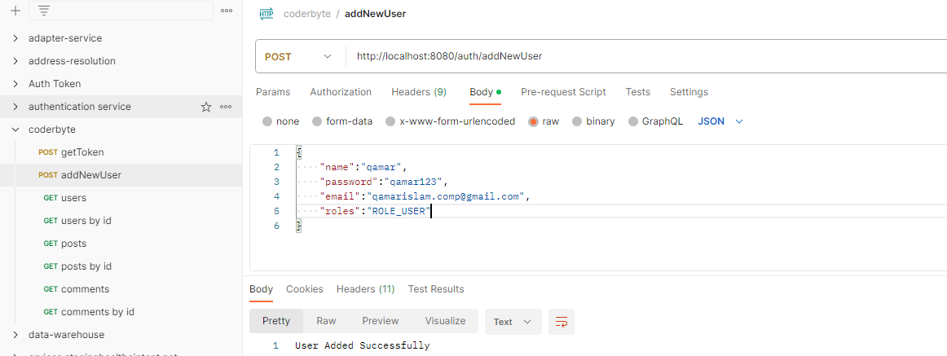

<http://localhost:8080/auth/generateToken>

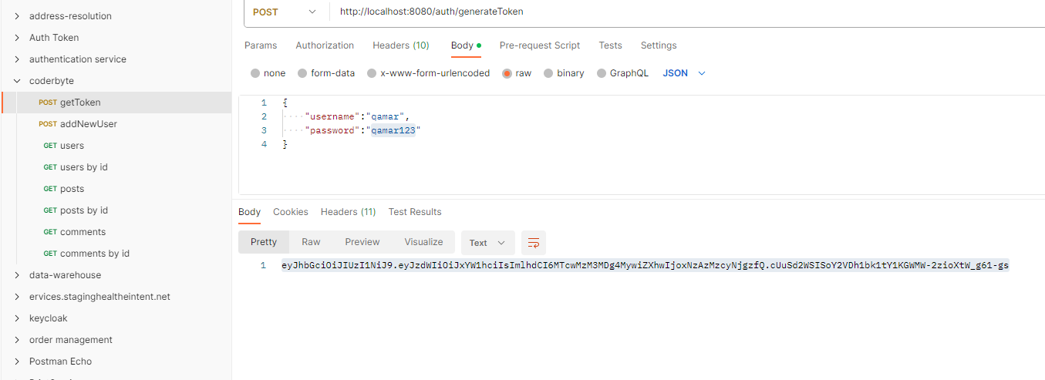

<http://localhost:8080/auth/user/users>

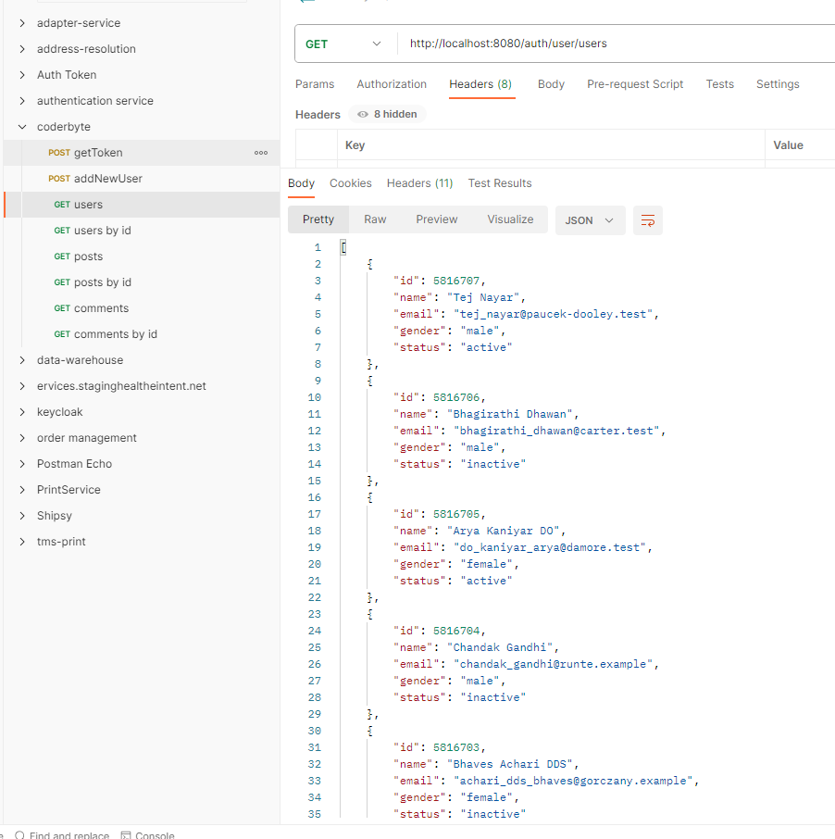

<http://localhost:8080/auth/user/users/5816706>

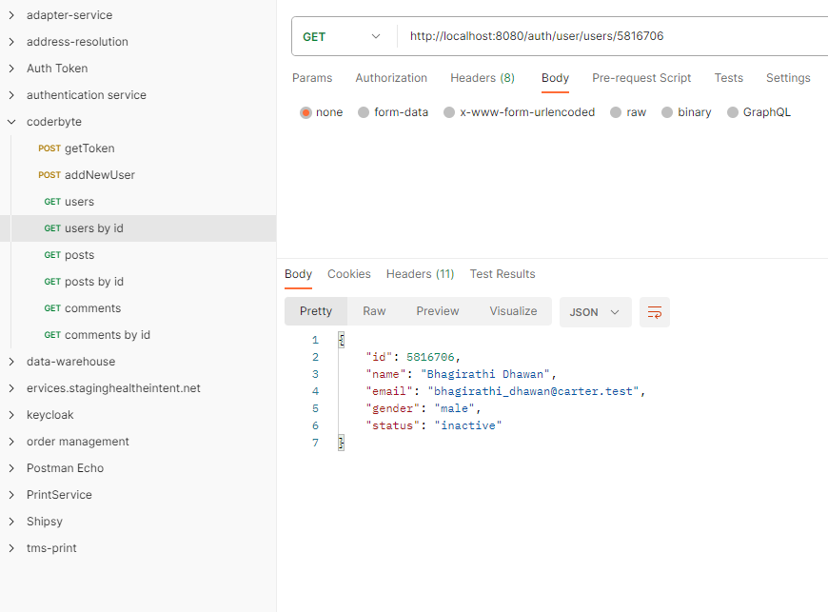

<http://localhost:8080/auth/user/posts>

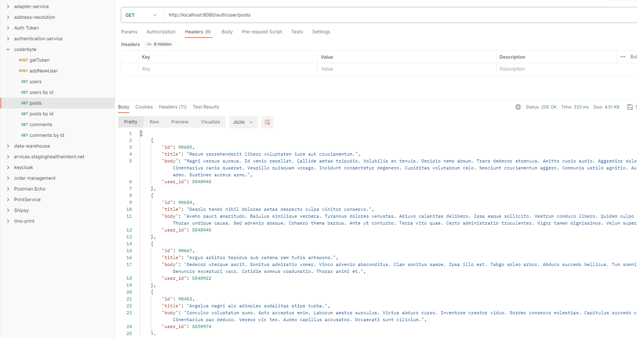

<http://localhost:8080/auth/user/posts/90685>

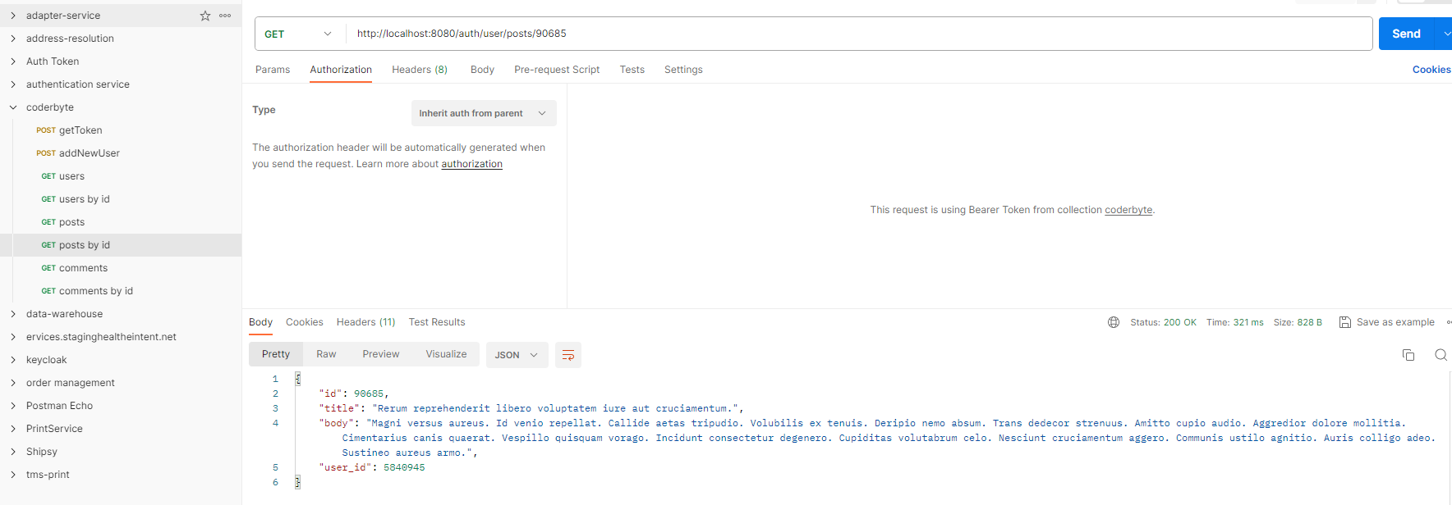

<http://localhost:8080/auth/user/comments>

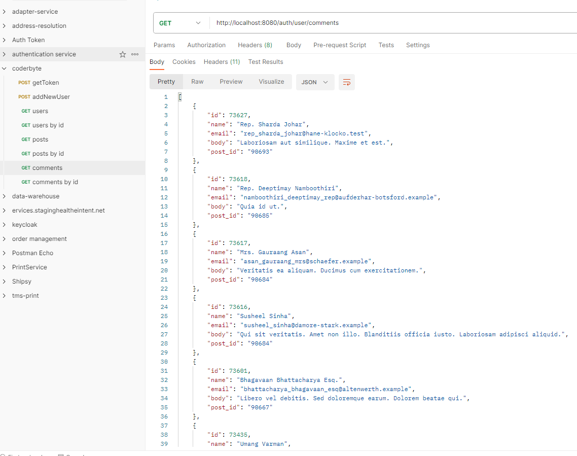

<http://localhost:8080/auth/user/comments/73627>

